FLOWCHART:

* Flowchart is defined as the pictorial representation of the logic for the problem
* solving.
* The purpose of flowchart is making the logic of the program clear in a visual representation.
* Flowcharts are better way of communicating the logic of the system.
* With the help of flowchart , a problem can be analyzed in more effective way.
* Flowcharts are used for good program documentation , which is needed for various purpose

SYMBOLS USED IN FLOWCHARTS

|  |  |  |  |  |
| --- | --- | --- | --- | --- |
| Serial number | Name of the symbol | Symbol | Type | Description |
| 1. | Terminal symbol |  | Oval | Represent the start and stop of the program |
| 2. | Input/Output |  | Parallelogram | Denotes either input or output operation |
| 3. | Process symbol |  | Rectangle | Denotes the process to be carried |
| 4. | Decision symbol |  | Diamond | Represents decision making and branching |
| 5. | Flow lines |  | Arrow lines | Represents the sequence of steps and direction of flow. Used to connect symbols. |

TOOLS USED FOR DRAWING FLOWCHARTS:

* GOOGLE DRAW - It’s a very good tool the flowcharts can be drawn very easily and the flowcharts are directly stored into the drive. But the page is limited to draw the flowchart.
* SMART DRAW - Smart draw is a very good tool to draw the flowcharts but we can’t save the flowcharts directly in the system and it cannot be used for free.
* CANVA - Canva is totally user friendly tool and we can use it for free without any subscription.
* DIAGRAMS.NET - In this tool the flowcharts can be saved easily but the output will not be that much precised.
* ZENFLOWCHART - The diagrams can be directly stored in the system and it has many good features to use. But in this tool only 20 shapes can be used for free but from 21st shape we need to pay and use it.
* VISUAL PARADIAGRAM - Visual paradiagram is also a very good tool used for drawing the flowcharts but one disadvantage is we need to pay for it

TO DRAW FLOWCHART AND WRITE ALGORITHM FOR THE FOLLOWING PROBLEM

EX NO: 1(a)

DATE:

STUDENT DATA ANALYSIS

AIM :

To draw and write flowchart and algorithm for student data analysis .

ALGORITHM :

Step 1: start

Step 2: read no of students

Step 3: initialize i =1

Step 4: if i<=n

Step 5: get name,rollno,m1,,m2,m3,m4

Step 6: calculate avg=m1+m2+m3+m4/4

Step 7:goto step 4

Step 8: if avg >=90

Step 9: grade = A

Step 10: if 90>avg >=70

Step 11: grade = B

Step 12: if 70>avg >=50 else goto step 13

Step 13: grade = C

Step 14: grade = D

Step 15: print name,rollno,grade

Step 16:stop

PSEUDO CODE

START

READ no of students

INITIALIZE i =1

IF i<=n

GET name,rollno,m1,,m2,m3,m4

CALCULATE avg=m1+m2+m3+m4/4 goto step 4

IF avg >=90 THEN grade = A

ELIF 90>avg >=70 THEN grade = B

ELIF70>avg >=50 THEN grade = C

ELSE grade = D

PRINT name,rollno,grade

END IF

STOP

FLOWCHART:

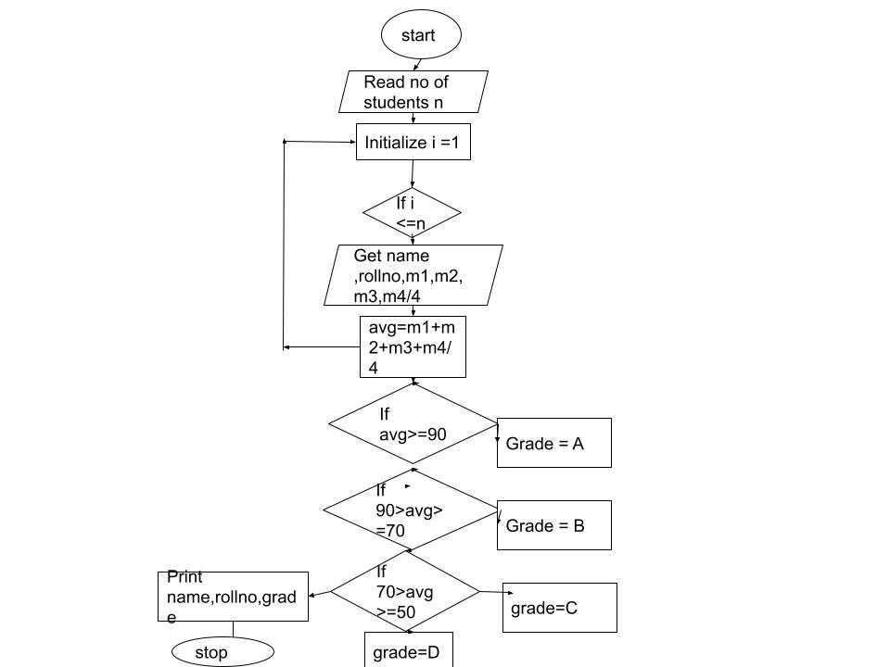

RESULT :

The flowchart and algorithm for the above program is written successfully

TO DRAW FLOWCHART AND WRITE ALGORITHM FOR THE FOLLOWING PROBLEM

EX NO: 1(b)

DATE:

WEIGHT OF A MOTOR BIKE

AIM :

To draw and write flowchart and algorithm for weight of a motor bike

ALGORITHM:

Step 1: start

Step 2: get goss vehicle weight rating GVMR

Step 3: get dry weight DW

Step 4: get fuel weight FW

Step 5: get rider weight RW

Step 6: get passenger weight PW

Step 7: calculate total = DW+FW+RW+PW

Step 8: get load

Step 9: calculate loadweight = total+load

Step 10: calculate safeweight=GVMR -loadweight

Step 11: if safeweight >=0

Step 12: print safe ride

Step 13: else

Step 14: Print for safe ride reduce the weight and goto step 8

Step 15: stop

PSEUDO CODE

START

GET goss vehicle weight rating GVMR

GET dry weight DW

GET fuel weight FW

GET get rider weight RW

GET passenger weight PW

CALCULATE total = DW+FW+RW+PW

GET load

CALCULATE loadweight = total+load

CALCULATE safeweight=GVMR -loadweight

IF safeweight >=0

PRINT safe ride

ELSE

PRINT for safe ride reduce the weight and goto step 8

ENDIF

STOP

FLOWCHART :

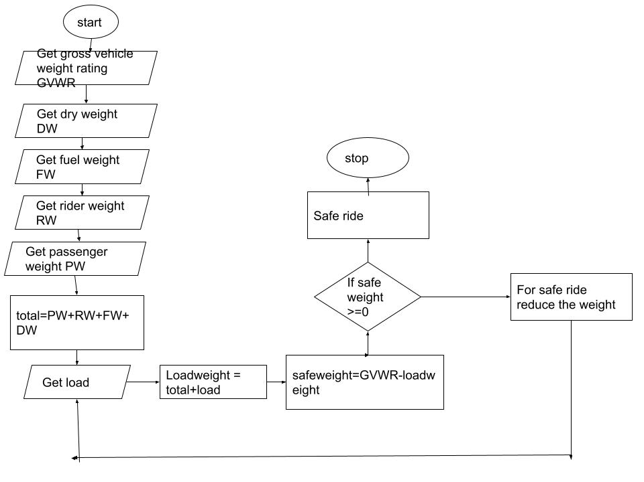

RESULT:

The flowchart and algorithm for the above program is written successfully

TO DRAW FLOWCHART AND WRITE ALGORITHM FOR THE FOLLOWING PROBLEM

EX NO: 1(c)

DATE:

WEIGHT OF A STEEL ROD

AIM:

To draw and write flowchart and algorithm for weight of a steel rod

ALGORITHM :

Step 1: start

Step 2: get no of rods n

Step 3: initialize I -1 and weight = 0

Step 4: if i<=n goto step 8 else goto step 8

Step 5: get diameter D and length L

Step 6: calculate weight = D*D*L/ 162

Step 7: goto step 4

Step 8: print weight

Step 9: print the weight of the rod

Step 10: stop

PSEUDO CODE

START

GET no of rods n

INITIALIZE i =1 and weight = 0

IF i<=n goto step 8

ELSE goto step 8

GET diameter D and length L

CALCULATEweight = D*D*L/ 162 goto step 4

PRINT weight

PRINT the weight of the rod

STOP

FLOWCHART:

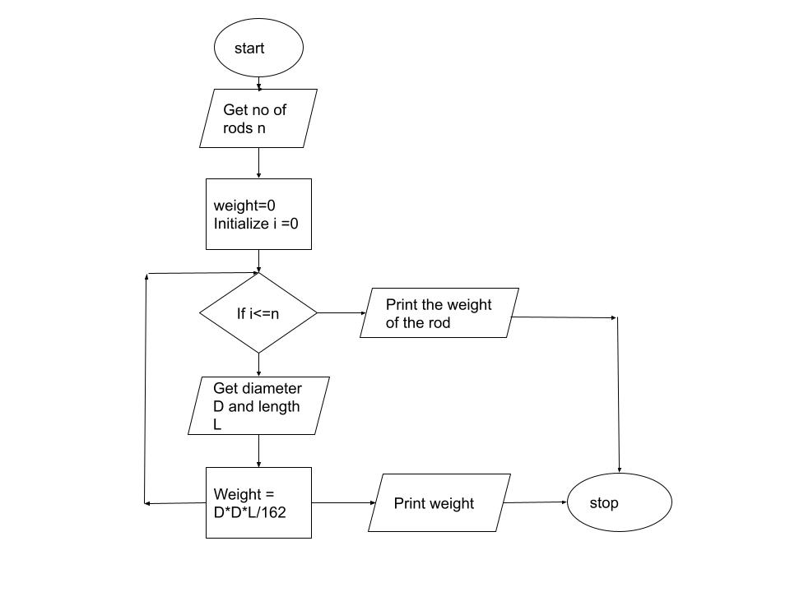

RESULT:

The flowchart and algorithm for the above program is written successfully

TO DRAW FLOWCHART AND WRITE ALGORITHM FOR THE FOLLOWING PROBLEM

EX NO: 1(d)

DATE:

RETAIL SHOP BILLING

AIM :

To draw flowchart and write algorithm for retail shop billing problem

ALGORITHM:

Step 1: start

Step 2: get no of items n

Step 3: initialize I =0 and bill=0

Step 4: if i<=n goto step 5 else goto step 7

Step 5: get quantity and price of the item

Step 6: calculate bill = quantity *price goto step 4

Step 7: if bill>=5000 goto step 9 else goto step 10

Step 8: calculate newbill = bill-bill*0.05 and goto step 4

Step 9: print newbill you have 50% of discount

Step 10: print bill and you have no discount

Step 11: stop

START

GET no of items n

Step 3: initialize I =0 and bill=0

IF i<=n goto step 5

ELSE goto step 7

GET quantity and price of the item

CALCULATE bill = quantity *price goto step 4

IF bill>=5000 goto step 9

ELSE goto step 10

CALCULATE newbill = bill-bill*0.05 and goto step 4

PRINT newbill you have 50% of discount

PRINT bill and you have no discount

STOP

FLOWCHART :

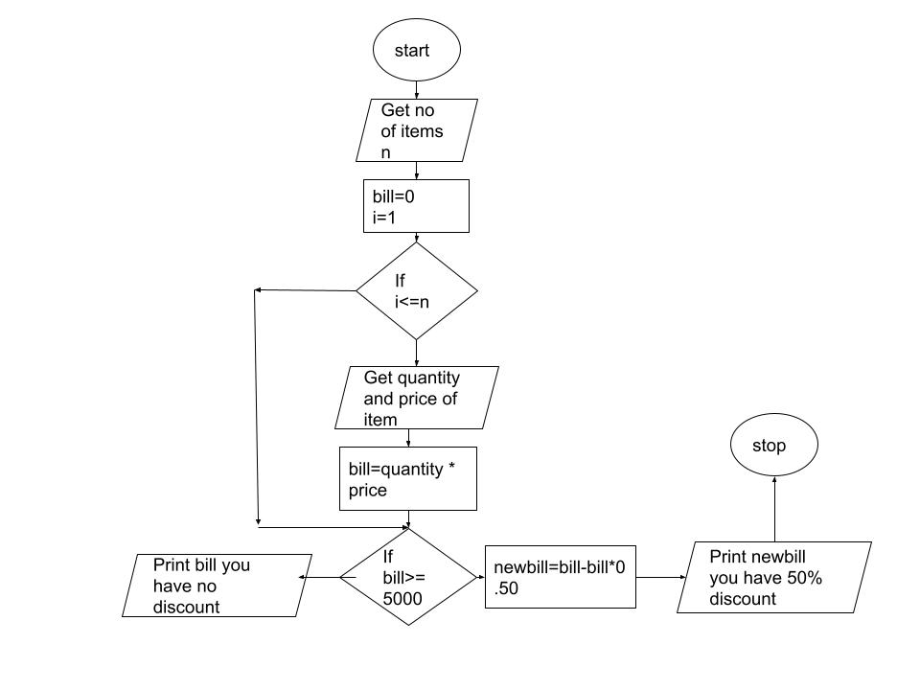

RESULT:

The flowchart and algorithm for the above program is written successfully

TO DRAW FLOWCHART AND WRITE ALGORITHM FOR THE FOLLOWING PROBLEM

EX NO: 1(e)

DATE:

CALCULATE ELECTRIC BILL

AIM:

To draw and write algorithm for calculating electric bill

ALGORITHM :

Step 1: start

Step 2: get the previous units and current units

Step 3: units = previous units – current units

Step 4: if units <=100

4.1: energy charge =0,fixed charge =0,duty charge=0

Step 5: if units <=200

5.1: energy charge =0 +1.5*(units-100), fixed charge =20, duty charge=18

Step 6: if units <=500

6.1: energy charge =3.5*(units-100), fixed charge =30, duty charge=48

Step 7: if units >7500

7.1: energy charge =4.5*(400)+6.0*(units-500), fixed charge =75, duty charge=100

Step 8:Bill = totalcharge +fixedcharge dutycharge

Step 9: display the current bill

Step 10:stop

START

GET the previous units and current units

CLACULATE units = previous units – current units

IF units <=100

THEN energy charge =0,fixed charge =0,duty charge=0

IF units <=200

THEN energy charge =0 +1.5*(units-100), fixed charge =20, duty charge=18

IF units <=500

THEN energy charge =3.5*(units-100), fixed charge =30, duty charge=48

IF units >7500

THEN energy charge =4.5*(400)+6.0*(units-500), fixed charge =75, duty charge=100

CALCULATE Bill = totalcharge +fixedcharge dutycharge

DISPLAY the current bill

STOP

FLOWCHART: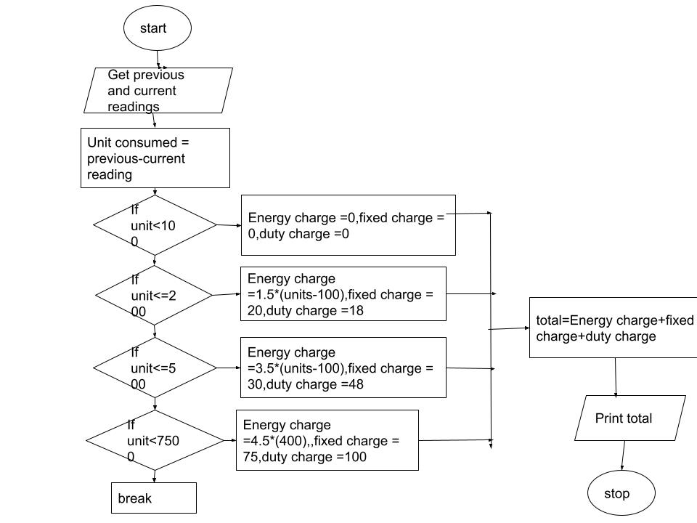

RESULT:

The flowchart and algorithm for the above program is written successfully

TO DRAW FLOWCHART AND WRITE ALGORITHM FOR THE FOLLOWING PROBLEM

EX NO: 1(f)

DATE:

CALCULATE SINE SERIES

AIM:

to draw flowchart and write algorithm for sine series

ALGORITHM :

Step 1: start

Step 2: read x

Step 3: read n

Step 4: initialize i=1

Step 5: declare PI = 3.142

Step 6: x= x*PI/180

Step 7: t= x

Step 8: sum = x

Step 9: for i <= n

Step 10: yes

Step 11: t = -t*x*^2/2*i(2*i*1)

Step 12: sum = sum +t

Step 13: increment i by 1

Step 14: goto loop

Step 15: no

Step 16: print sum

Step 17: stop

PSEUDO CODE

START

READ x

READ n

INITIALIZE i=1

SET PI = 3.142

CALCULATE x= x*PI/180

SET t= x

SET sum = x

FOR i <= n

THEN

CLACULATE t = -t*x*^2/2*i(2*i*1)

CALCULATE sum = sum +t

INCREMENT i by 1 and goto loop

ELSE

PRINT SUM

STOP

FLOWCHART:

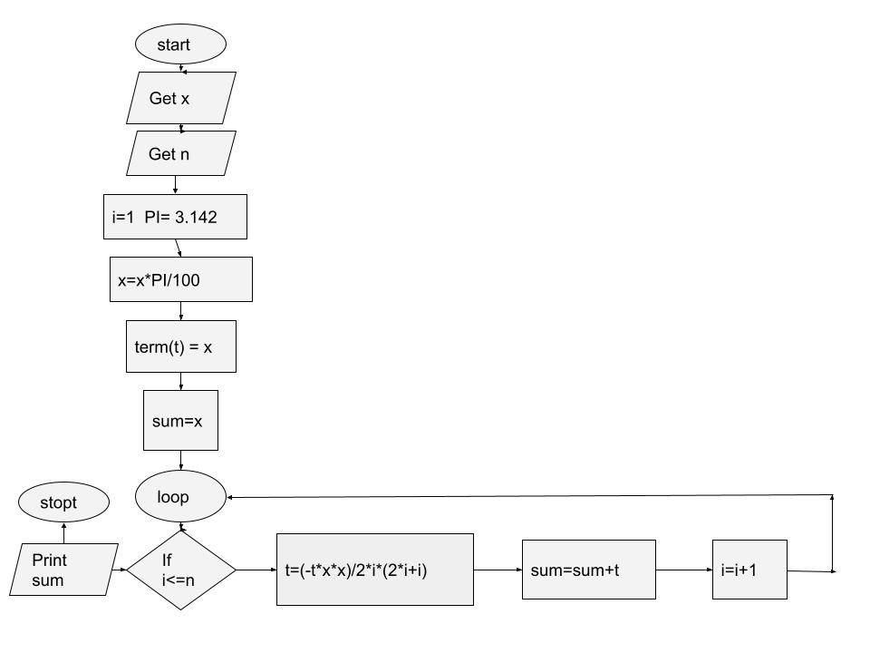

RESULT :

The flowchart and algorithm for the above program is written successfully

TO DRAW FLOWCHART AND WRITE ALGORITHM FOR THE FOLLOWING PROBLEM

EX NO: 1(g)

DATE:

COMPUTE ELECTRICAL CURRENT IN 3-PHASE AC CIRCUIT

AIM:

To draw flowchart and write algorithm for computing electrical current in 3-phase AC circuit

ALGORITHM:

Step 1: start

Step 2: read values of PF,I and V

Step 2: Calculate P = 1.732*PF*I*V

Step 2: Print current P

Step 2: stop

PSEUDO CODE

START

READ values of PF,I and V

CALCULATE P = 1.732*PF*I*V

PRINT current P

STOP

FLOWCHART: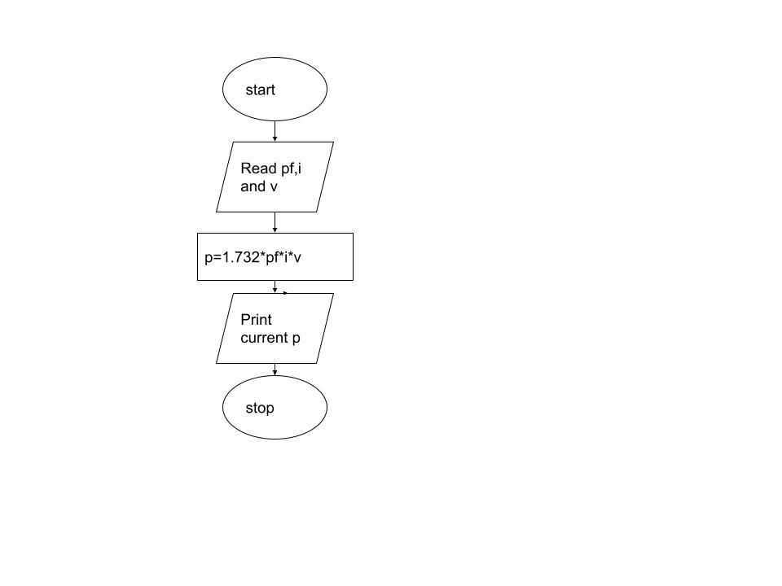

RESULT:

The flowchart and algorithm for the above program is written successfully